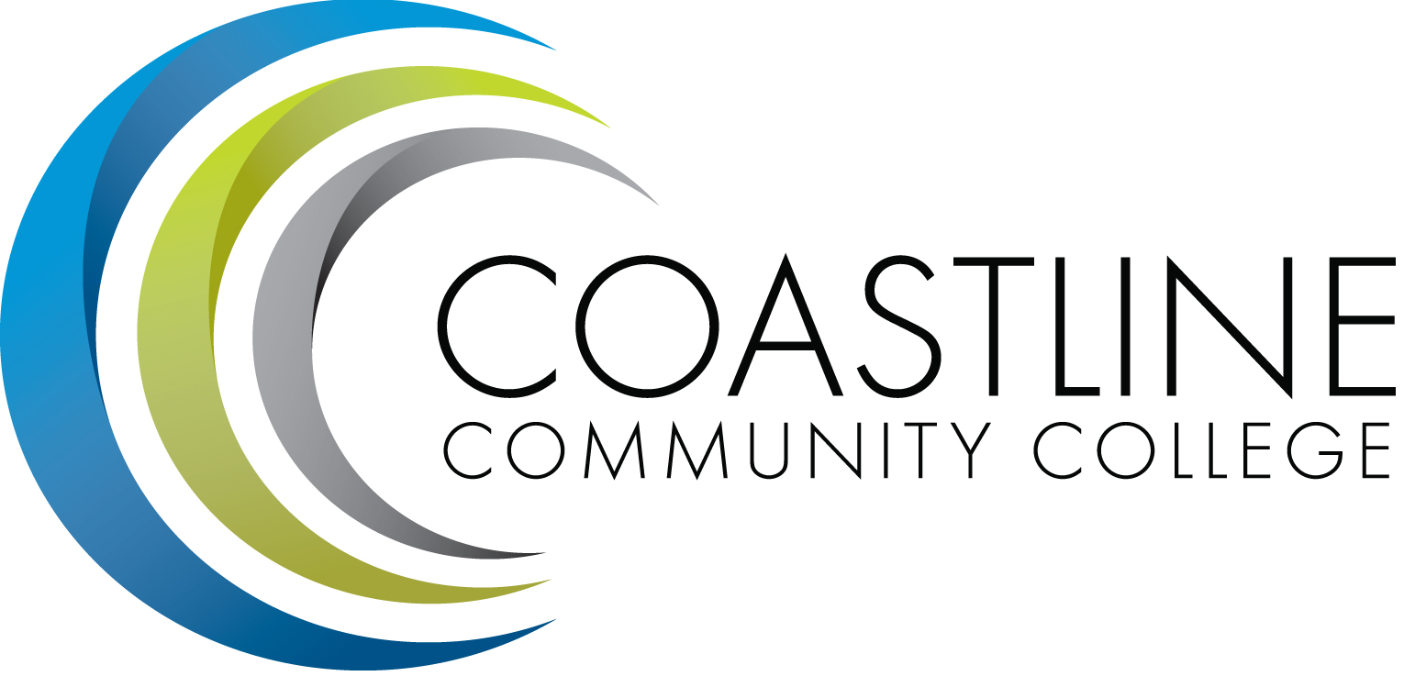

ACADEMIC SENATE
October 3, 2017 12:30 p.m. - 2:30 p.m.
College Center--Fourth Floor Conference Room
AGENDA
College Mission Statement: Coastline Community College steadfastly focuses on providing access and supporting student success and achievement. Inspired by an innovative and student-centered mindset, Coastline delivers flexible courses and services that cultivate and guide diverse student populations across the globe to complete pathways leading to the attainment of associate degrees, certificates, career readiness, and transfer to four-year colleges/universities.

12:30 p.m. 1. CALL TO ORDER: President Stephen Barnes
1.1 Pledge of Allegiance
1.2 Roll Call
1.3 Welcome
1.4 Adopt Agenda
1.5 Approval of Minutes –September 5, 2017 **
1.6 Consent Calendar
1.6.1 Approve Angela Gomez-Holbrook to serve on the District Equivalency Oversight Committee
1.6.2 Approve Amy Evangelista and Claudia Stone to serve on the VP Student Services Search Committee
1.6.3 Approve Marilyn Fry to serve on the District Equivalency Committee for English
1.7 Public Comment and Statement: Members of the public can address the Academic Senators on any item that has been described in this notice, before or during consideration of the item. Persons wishing to make comments are allowed three minutes.

2. DISCUSSION AND ACTION ITEMS
2.1 Prioritization Rubric**
2.2 Multiple Measures Pilot Extension

3. DISCUSSION ITEMS
3.1 RSI/LDA
\ 3.2 Placement Test Prerequisites-Lisa Lee/Fred Feldon
3.3 Integrated Plan-Julie Mendez*

4. SPECIAL PRESENTATION
4.1 Career Center-Paolo Varquez
4.2 Intercultural Resource Center-Paula Votendahl
4.3 Transfer Center-Helen Ward
4.4 Foundation-Mariam Khosravani
4.5 OER Conference-Lisa Lee/Chau Tran
4.6 College Center Renovation Update-Stephen Barnes

5. COLLEGE COMMITTEE REPORTS
5.1 PIEAC-Stephen Barnes
5.2 Budget-Rick Lockwood
5.3 Facilities-Michael Warner
5.4 Technology-Cheryl Chapman
5.5 Professional Development & Leadership-Lisa Lee
5.6 Student Success-Ann Holliday
5.7 Curriculum-Dan Johnson
5.8 Accreditation-Danny Pittaway

6. SENATE SUBCOMMITTEE REPORTS
6.1 Academic Rank-Michael Warner
6.2 Academic Standards-Ann Holliday
6.3 Budget-Ann Holliday
6.4 Communications-David Lee
6.5 Elections-Margaret Lovig
6.6 Faculty Recognition-Ann Holliday
6.7 FSC-Rick Lockwood, Cheryl Chapman
6.8 Policy and Procedures-Deborah Henry
6.9 Social-David Lee

7. ANNOUNCEMENTS: (1-minute limit – please sign list to speak)

2:30 p.m. 8. ADJOURNMENT

*Hand-outs available at meeting.
**Copies have been sent to Senators. Others who would like a copy should contact the Senate office at academicsenate@coastline.edu.
Refreshments
Noha Kabaji and Linda Kuntzman
Contact the Senate Office ~~ We welcome your input!
Stephen Barnes (714) 241-6156 ~~ Email: academicsenate@coastline.edu
Academic Senate Website: http://www.coastline.edu/academicsenate/
Zoom Link: https://zoom.us/j/619853943

NOTES AND NEWS
Stephen Barnes, Academic Senate President
October 3, 2017

- Cybersecurity Awareness & Tech Expo, October 13, 2017, GGC Room 315; 6:00 – 9:00 p.m. Please contact Judy Garvey at ext. 16186 for more information.

- UC San Diego Webinar, October 24 & November 16, 2017, 3:30 p.m. Please contact the Transfer Center at transfercenter@coastine.edu for more information.

- ASCCC Area D Meeting: The Fall 2017 Area D meeting will be on October 14 from 10:00 a.m. – 3:00 p.m. at Fullerton College. An agenda and other meeting materials will be posted in early October. Please contact the Academic Senate Office at ext. 16156 if interested.

- ASCCC 2017 Fall Plenary Session: November 2-4, 2017 at the Irvine Marriott. For more information please go to: http://www.asccc.org/events/2017-11-02-150000-2017-11-04-230000/2017-fall-plenary-session, and contact Academic Senate Office as soon as possible if you plan to attend.

- Veterans Day Holiday: Friday, November 10, 2017; All Coastline Campuses are closed.

- Thanksgiving Holiday: Thursday, November 23 and Friday, November 24, 2017; All Coastline Campuses are closed.

NEXT MEETING

Date: October 17, 2017

Refreshments: Rick Lockwood, Chau D. Tran

